LinkedDominator 2.0.0.8

# System Design Documentation

1.0.0.1

**Document History:**

**Created By: Prabhat Sinha**

|  |  |  |  |
| --- | --- | --- | --- |
| Revision Number | Revision Date | Version | Description |
| 1 | 23-Dec-2014 | 1.0.0.1 | This document has been cover all features and technical part of LinkedDominator. |

**Overview:**

This is a technical blueprint for the project. This document has been developed by Technical Department of Linked Dominator for the website <http://www.linkeddominator.com/>. LinkedIn provides numerous social media advertising solutions to increase brand awareness and lead generation. You can reach the most influential and educated audience with your well-managed LinkedIn marketing strategies.

**Table of Contents:**

1. **Main Features Page#**

1.1 LinkedIn Search 4

1.2 LinkedIn Scraper 7

1.3 Status Update 9

1.4 Add Connection 11

1.5 Create Group 13

1.6 Join Friends Group 15

1.7 Join Search Group 17

1.8 Group Status Update 19

1.9 Compose Message 21

1.10 Message Group Member 23

1.11 Proxy Setting 26

1.12 Endorse Your Profile 28

1.13 Profile Ranking 29

1.14 ShareLink 30

1. **Other Features**

2.1 Accept Invitation 29

2.2 Invite Member through Profile URL 30

2.3 Status Update Liker 32

2.4 Join Group Using URL 33

2.5 Follow Company Using URL 34

2.6 Remove Pending Group 35

**3.1 Technology Used**

3.1 Licensing

3.2 Database

3.3 LD Modules

**1.1 LinkedIn Search**

a) Before starting the process please select the account in the dropdown from you which you want to run the process.

b) The search is based on two things that are based on keyword and other one is based on company.****

c) Select one category from the dropdown you want to search then type in the corresponding data you want to in the below the text field.

## d) After you are done with that press the START button and then you can see the process running in the logger.



e) After the process is complete you will get a final completion message in the logger.

f) After that go the output folder in the desktop and there you will find a excel sheet created by the software for the search you have done with the software.



g) The result file will look like this.



h) This is how the interior of the result file will look like. It will contain all the data that is visible in a profile.

1. But if you have the profile Urls of the profiles you want to scrape then you can directly take the profile Urls.



j)And put them in a text sheet and upload them in the software. k) Press START button and the result file will be created.

k) Press START button and the result file will be created.



l) This is all about LinkedIn search module.

**1.2 LinkedIn Scraper**

This is one of the powerful feature in the market for scraping profiles in LinkedIn. It has all those filters that LinkedIn has in their advance search section.

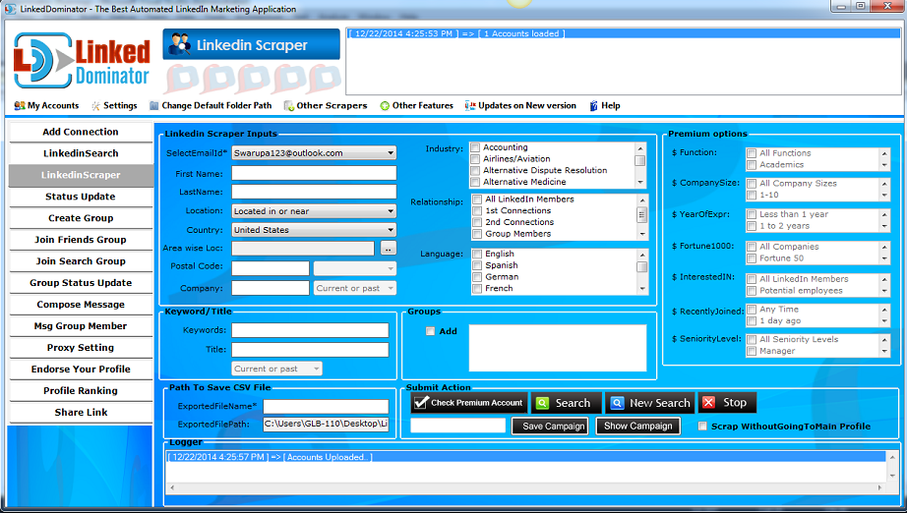

a)This is how the famous scraper looks like.

b)The process is just similar like the LinkedIn Search module. The good thing here is you don’t need to upload any text file.

c) Just write down the data in the fields provided and the put one name for the out put file in the “ExportedFileName” field.

d)Then you will get the exported file



e) And the data will look like this…



f) It’s very simple to run the software. Just START and STOP

**1.3 LinkedIn Campaign Scraper**

This is one of the powerful feature in the market for scraping profiles in LinkedIn. It has all those filters that LinkedIn has in their advance search section and save with campaign more than one campaign run at a time, same time we have created one csv for each campaign.

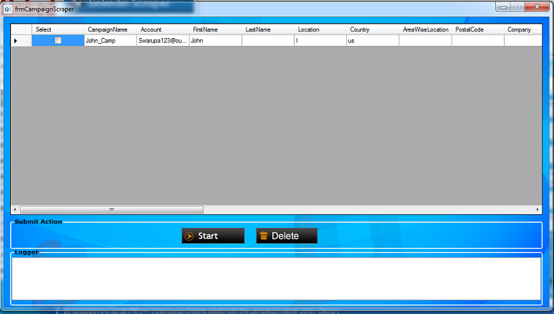

**1.3 Status Update**

If you want to share your thoughts with the LinkedIn members then there is nothing better than updating your status in your LinkedIn profile.

Status update help you with that.



a)This is a feature that will post a update on your account.

b)You need to write down the status one after another in a text file.



c)The software will take the first line and will post the line in your first account uploaded.

d)It works on one on one basis.

e)But if you want to upload a link or a YouTube video in your account then you can select the check box “UpdateUsingURL” and the job is done.



f)After the process is complete you will get the result file in the output folder in your desktop.



g)Open that and it will show you the updated along with the account.

**1.4 Add Connection**

If you want to send connection request to certain people (related to any keyword) or you have bunch of emails to whom you want to add in your connection then you can have this feature and send connection request to people in both ways.



a)If you have a list of emails then write them down in a text file and upload them in a ‘upload email load’ section.

b)If you want the invites to be divided equally among the accounts and the list of email you have uploaded then tick the email load checkbox.

c)And there is a option in which you can select to have each email to receive a single invitation only from a account.. For that to happen you need to tick the ‘Unique Connection’ check box and then you can proceed accordingly.

d)Once you have selected your preferences then press ‘Send Email Invite’ button and wait for the process to get complete.

e)Once the process gets complete you will see a process completion message in the logger.

f)But what if you don’t have emails then in that case you can go for another sub-module which is ‘Manage Connection search keyword’ .

g)There you need to write down the keyword in a text file according to which you need to send the connection. Save that file and upload the file in

h)‘Keyword load’ section and select the count in ‘Number of request per keyword’ section which will decide that per account how many connections will be sent.

i)Once you have setup everything then you can press ‘Search Connection’ button. Wait for the process to get complete and then you can check in your account regarding the progress

j)For every process you will get a output file created in the folder.

**1.5 Create Group**

Want to start a group then there is nothing better than create group feature to create groups of your choice in minutes.

It will help you in creating many groups with different filters at a time.



a)For creating group, it is very easy to do with LinkedIn Dominator.

b)You just need to upload the necessary data written in a text file and feed them to the software. And after that Press “create group” button.

c)It will create you the certain group with the features you wanted to be in your group.

d)In a similar manner how all the modules get their output file, here also you will get the file created inside the folder “LinkedIn Dominator” .

e)It contains a special feature which is known as “ Add you friends In Your Group”

f)What happens here is you need to put the url of the group.

g) Please make sure that where ever in the software you are uploading any group urls, it should be in this following format (**http://www.linkedin.com/groups?gid=2319076**)

h)Every url you pick should contain till the gid (group id) number.

i)Now this feature will send all your first connection invites to join the group you created.

j)The excel file will look like this.

k)And the data inside this will be in this following format



**1.6 Join Friends Group**

Want to join the groups which your friend has joined then you can have this feature and you can find out the full group list of your friend and then you can join those groups according to your choice



a)It’s a very simple and powerful module.

b)What if you are following your friends in LinkedIn and you want to join your friend’s all/specific groups.

c)This module “Join Friends Group” will help you with this.

d)First click on “add friend” and wait for the process to get complete in the logger.

e)Pressing that button will add all the friends of the accounts you uploaded in the software.

f)Once the process is complete, select the email id from the drop down and then you will get the list of first connection in the box given.



g)Now select the friends whom you want to join the set of groups.

h)Now you need to select the group which you want to join.

i)Select the group and press “Join Group” button and the accounts you loaded will go and join the group you selected of your friend.



j)This output file will contain the account email id along with the joined group.

**1.7 Join Search Group**

Don't have time to search group of your choice manually then you can use this feature where you need to type in the keyword of your choice according to which software will return you the list of groups. Then you can join any of them according to your choice.



a)If you want to join some groups related to some particular niche then it would be very easy for your accounts to search and join them using this module.

b)Type in the word in the “Search Keyword “whose groups you want to join and specify the number of groups you want the software to find for you.

c)Press “Search Groups” button and then it will find you those many number of groups related to that keyword in the box given in right side.

d)After you select the group which you want to join you can press the “Join Group” button and then the accounts uploaded will go and join the groups you selected above.

e)As like the other modules, this module will also give you the output file with all the accounts loaded and which group you joined will be there.



f)The output folder will contain two files, one will indicate the file containing the list of groups joined and the other file will contain the list of groups that were not abled to joined.





g) The successfully joined group will contain this data.

**1.8 Group Status Update**

Want to share or promote something with the group then you can have the them share with your group using this feature.

It update all your status at the respective group at a time. [www.linkeddominator](http://www.linkeddominator).



a)This is the module which will help you in getting the status updated in the groups in which you are a member.

b)It is very simple as like compared to other modules.

c) You just need to write down “Status Header” and “More Details” in two separate text files and upload them in the respective text fields.

d)Let’s start with pressing “Get Group” button and wait for the process to get complete.

e)After you get the list of groups, select the group to which you want to post a update.

f)Upload the necessary txt files in ‘Status Header’ and ‘More Details’ section.

g)Press ‘Send Update’ button and wait for the process to get complete.



h)Once the message is posted in the group, you will get a message saying the process is complete and there will be a file generated in desktop with the process details.





1. The data present inside in this will look like this.

**1.9 Compose Message**

Want to do bulk message to all of your connections and you don't have time for that then you can compose message feature



a)We will begin with fetching the 1st connection list from a user profile.

b)Press ‘Message From’ button at first and wait for the process to get complete.

c)Once the process gets complete you will get the list of all the 1st connection list in the window placed below.

d)Now from there you can select the connection or all connection to which you want to send message.

e)Once you have done that you can now go to the ‘Compose Message Input’ section and there you can write in the message Subject and Body.



Note:

1.We have option of spintax text which will help you in sending unique message to each and every connection you want to receive the message sent by you.

2.You can also use the message setting where in you select the option to send message with tag or without tag.

**1.10 Message Group Member**

Want to message to people who are not in your contacts then you can use this feature which will help you to message group members at a time and that too in bulk. It also have a advantage that don't allow a member to receive duplicate messages.



a)One of the powerful and effective tools in the LinkedIn market which allows you to send bulk/personal message to your group members even if they are not in your connection.

b)The two things which we will be needing to start the process are the groups and their members. Software will get those groups who are in active status and you are a member of it.

c) Lets start with by getting the list of groups of the account you have uploaded.

d)Press ‘Get Group’ and wait for the software to fetch the list of group.



e)In the logger you will get a message which will opt you to select the account.

f)Select any particular account and then select the group from the list of group that will come at the dropdown.

g)Once you have selected the account and its group, press ‘Get Member’ button and wait for the process to complete.

h)Once the process gets complete you will get a message in logger that will opt you to select the members to whom you want to send message.

i)Select the list of members to whom you want to send message.

j)Now move to ‘Message Input’ section and write down the message subject and message body. After you have done that press ‘Send Message’ button.

Note: We have two option that avoid a member from getting a message twice, to avoid spamming.

1.Prevent Message Duplicacy (Group Specific)– this will avoid a member from getting the same message twice in a particular group.

2.Prevent Message Duplicacy (For Any Group) – this will avoid a member from getting a same message twice in any group.



h)The output file will contain the list of accounts along with the message sent to it.



**1.11 Proxy Setting**

You want to have proxies with your account or you want to just test them then you can use this feature to test private/public proxies and then you can assign them.



a)It has two section

**1.11.1 Public Proxy** If you have public proxies with you which you want to use with the software or accounts then write down them in a txt file and upload that in the public proxy section and then press ‘Test’ button and it will give you a text file with all the working and non-working proxies kept separately in different text files. Clicking on ‘Assign Proxy to Account’ will assign the working public proxy tp the uploaded accounts in the software.

**1.11.2 Private proxy**

If you have private proxies with you which you want to use with the software or accounts then write down them in a txt file and upload that in the public proxy section and then press ‘Test’ button and it will give you a text file with all the working and non-working proxies kept separately in different text files.

Clicking on ‘Assign Proxy to Account’ will assign the working private proxy tp the uploaded accounts in the software.





It will create two files which will contain the list of working and non-working proxies which were found after testing with LinkedDominator.

**1.12 Endorse Your Profile**

Want to have your skills endorsed or you want to endorse someone's skills then you can have this feature and you can endorse their profile



a)If you want your 1st connection’s skill to be endorsed then there is no better tool then this.

b)You just need to get the ID from the profile URL of your 1st connection. Paste that ID in a text file and upload that in the module.

c)Press ‘Start’ button once you have uploaded the text file and then the software will endorse the skills which It will get in the first hit.

**1.13 Profile Ranking**

We fetch you rank of your profile among your connection along with percentile. Also, we fetch name and rank of your top 10 connections.

Along with that we give you number of your profile views in total and number of profile views with different keywords used.

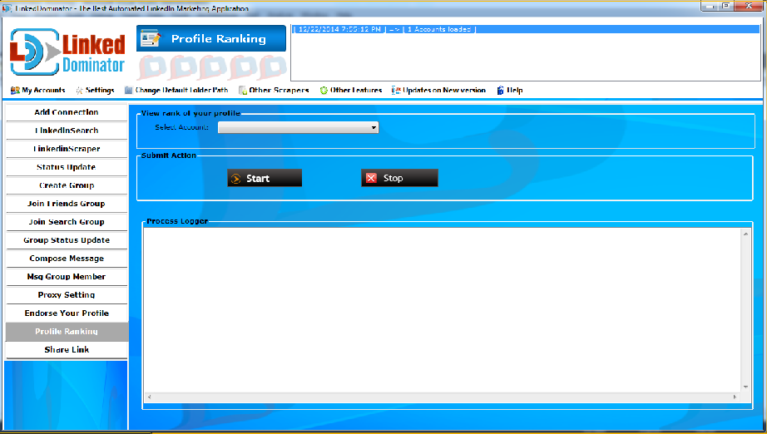

**1.14 Share Link**

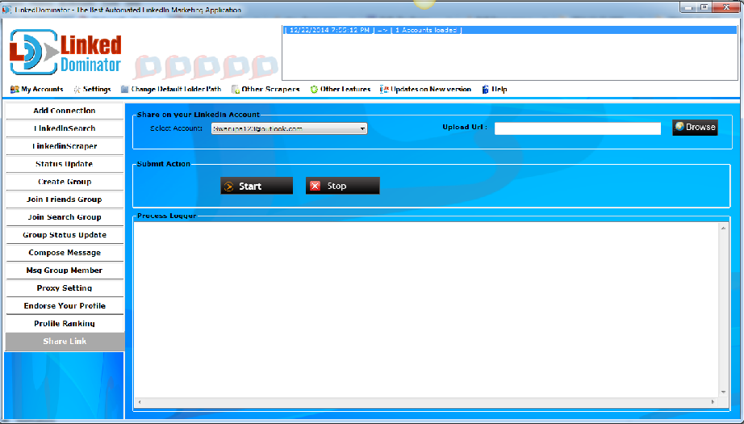

**2.1 Accept Invitation**

Do you have many invitations received in your profiles and its boring to accept everyone one after another. Our module makes it easy for you as it accept all your invitation at a time.



a)Its very simple to use this module.

b)You just need to press the “ Accept Invitation “ button and the software will accept all the invitation present in all the profiles you uploaded.

c)Once all the invitations are accepted you will get a message indicating that the process is completed for accepting invitation.

**2.2 Invite Member Through Profile url**

Do you have lots of profile urls to whom you want to send invitation then you can upload them all in this module and software will send them invitation to all of them at a once.



a)The first step will be to get the url of the profiles.

b)Copy and paste the profile url in a text file and save it.



c)Now upload that saved text file in profile url section.

d)After you have uploaded the required file press ‘ Send Invitation ‘ button and wait for the process to gets complete.

e)Once the process gets complete, you will get a message in the logger sating that the process is complete.



f)This will be the resultant file created in the output folder.



h) This will be the final data that will be present in the resultant file created after the process gets complete.

**2.3 Join Group Using url**

Do you have the urls of the groups and you want all the profile to join them then our module will help you with that. It will allow all the accounts loaded to go and join the groups you have uploaded. [www.linkeddominator](http://www.linkeddominator).



a)If you have a list of group urls which you want your list/single account to go and joining in a matter of minutes then you can use this module.

b)You need to upload the list of group url in the following format. ‘ https://www.linkedin.com/groups?mostRecent=&gid=83347 ‘

c)Please ignore the rest of the characters came along with the url, you just need the url till the gid number.

d)Take the list of urls and paste them in a text file and save them.

e)Now upload that txt file in ‘group url’ section and select the ‘No of group per account’ which will decide that how many groups per account will be added.

f)Once you are done with it press ‘join group’ button and wait for the process to get complete. You will get a message of process completion in logger which will get indicate that all the accounts which you have uploaded have joined/not joined the groups.

**2.4 Follow Company Using url**

You want to follow a company with all the accounts you have then software will help you with that. Just upload the company url and software will go and follow them.



a)If you have a company or you want to increase the follower of a certain/list of companies then in that case you have use this powerful feature present in LinkedDominator to follow them.

b)You just need to copy and paste the company’s url in a text file and save it.

c)Go to ‘Company url’ section an upload the text file where in you saved the company url and select ‘No of Company per account’ count which will decide that how many companies will be followed by how many accounts.

d)Once you are set press ‘Follow Company’ button and wait for the process to get complete. You will get a process completion message in the logger which will indicate that accounts have followed the companies you have uploaded.

**2.5 Remove Pending urls**

Joined many groups and many of them have not granted you access to the group then with the help of this module you can unfollow all of them at a time.



a)You might have joined many groups for which your access is in waiting status. And due to this pending status you are not allowed to join more groups.

b)Click on ‘Add Pending Groups’ and wait for the software to fetch the list of pending groups.

c)Once you get the groups select the particular account from the dropdown whose pending groups you want to remove.



d)Now select the pending group to which you want to remove from the account.

e)After selecting the particular group/ groups, press ‘Remove Pending Groups’ and wait for the process to get complete.

f)Once the process gets complete, you will get a message in the logger saying that the pending status group has been removed and along with that you will get a file in the output folder containing the details of the name of the group along with the corresponding accounts.

**3.1 Technology Used:**

.Net (Winforms) – It’s the core technology used to build this robust desktop app with manageable multithreading.

**3.1 Licensing:**

Php – php script is used for licensing purpose, its attached with same site url.

Licensing process is basically three types,

1. 3 days free trial, free trial is automatic activated if s/w run add ldfreetrial in transaction ID field after 3 days its automatic expired and during 3 days its only work with 5 accounts.
2. One month licensing.
3. Lifetime licensing.

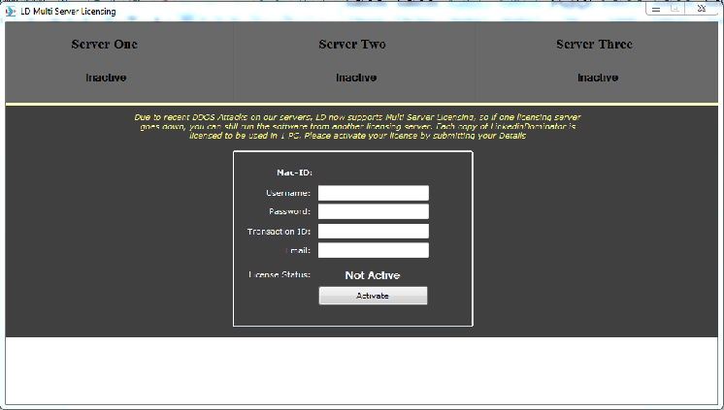

* 1. **Database**

SQLite – Here we store all the relevant details for the LinkedIn accounts used by the application user, campaigns, posts, and many more. We store this database locally in App Data folder.

Path: C:\Users\GLB-110\AppData\Local



LD DbEntity Design:

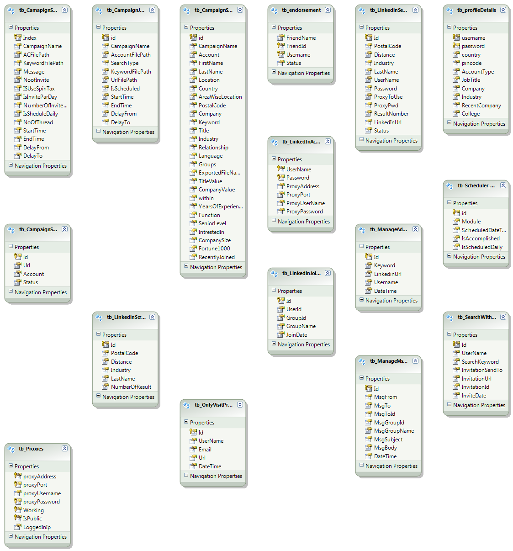

MySQL – this is used for Licensing, User registration details, package, status.

**3.3 LD Modules:**

Baselib (Class Library) – It’s a library which contains all the methods/functionalities which other projects in the solution would use.

Functionalities of Baslelib:-

1. Making all Http Web Requests like Get, Post, Multipart uploading. Managed cookies between requests.
2. File Handling methods like Reading/Writing into Text/CSV, Excel.
3. String operations, Spinning, Random number generations.
4. Events classes for managing events firing, and passing data through events

It also contains local Database connection, Query manager classes, CRUD operations wrapper for SQLite local Database.

Other Class Libraries (Account Info, StatusUpdate,GroupUpdate,CreateGroup,ManageConnetion,JoinSearch Group, Compose Message, Massage Groups member, LinkedIn Scrapper)

These are libraries which include the CORE functionalities like Posting Message to LD Group Members, connecting Friend, status/msg Posting, mail sending to 1st groups also send group members. These libraries are referenced by Linked Dominator project which connects these libraries with the UI.

Linked Dominator (Windows Application) – It’s the main front end, UI, connects UI with the functionalities in other class libraries, also with the Baselib.  
So, in all it is the interface which end user sees and make settings, sees logs, data grids, and details of operations performed.